# Website Plan—Assortment of programming projects

## Line drawing

Inspired by the website Linify.me and a reddit post, I originally wrote this program in java and ported it to javascript for this class. This page will just have the actual project (that the user can use) on it and link to a page that has a description of the algorithm.

## Line drawing information

This webpage will be a description of how the line drawing algorithm works, talking about how lines are drawn for each color channel trying to maximize the amount of information transferred from the image to the output canvas. (There will be an image and a line-version of that image on this page)

## Image filters

The user will be able to upload (or put the url of) an image and be able to choose some things to happen to that image. The filters I’m planning on making are: dithering, edge detection, blurs, edge enhancement (I might add more but this is all I’m planning right now). This page will link to another page that explains how these filters work.

## How image filters work

This page will just explain how each filter works and I’ll show some before and after images of each of the filters.

## Cellular Automata

This page will have some cellular automata simulations I’ll write. The ones I’ll implement are Conway’s Game of Life, Langton’s ant, and a predator-prey simulation. The user can run these and change their properties. This will link to a page that explains these cellular automata and their rules.

## How Cellular Automata work

This will just explain what the cellular automata on the previous page do with maybe some images to illustrate some concepts like neighbors.

Note: on all of the information pages I’m either going to link to my inspiration for the projects or some more helpful resources like a Wikipedia article that explains a concept more in depth.

For the webpages that do more than one thing (the cellular automata one for example where there will need to be multiple simulations) I will just put a bar at the top or on the side or something where you can select which filter/automaton you want to use. I’m thinking of laying out the website like this.

Bar at the top that has my name and a link to send you back to the home page.

On the left side of the screen there will be a small panel running down the length of the screen that will have links that let you jump to any page.

On the right of the screen there will be another bar like the one above but it will let you switch between filters/automatons and show all of the variables you can mess with.

In the middle of the screen, taking up the most space, will be the actual content window that will have either my text for the informational pages or the project for the functional webpages.

Here’s a mockup (name pending change):

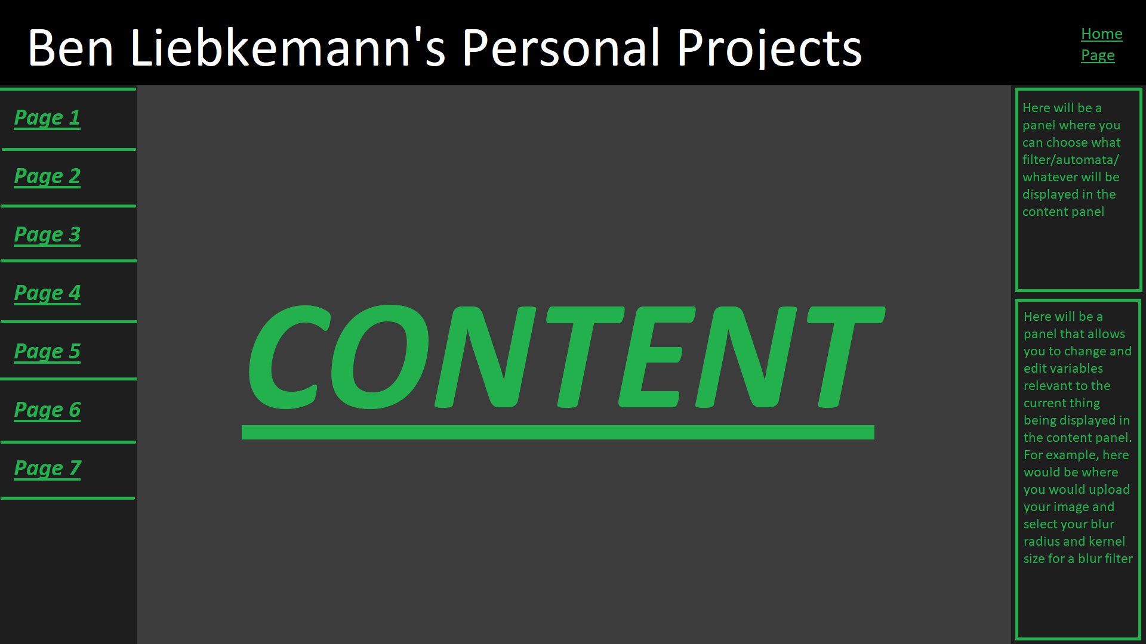

The “Page 1, 2, 3, 4, 5, 6, and 7” on the left will be replaced with the actual names of those pages. I think that when the window is resized, I’ll make it so that the bars on the left and right stay a consistent size but the content in the middle shrinks.

I’m making all of these projects from scratch using javascript so I have all rights to the code I write. In terms of images: any example images I use I will take or make myself. Part of the user interactivity comes from the user uploading or finding their own images so that’s not an issue. Those user-uploaded images also aren’t hosted on or saved by the site so there’s no issue.